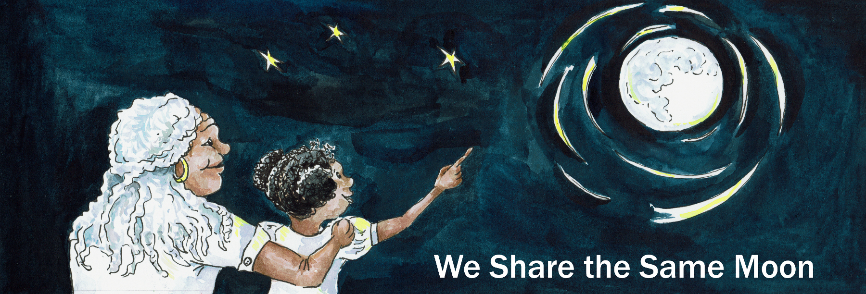
Suggested Age Range: 7- 8 years; 8 - 9 years; 9 - 10 years; 10 - 11 years
UK Curriculum: Key Stage Two (Lower), Key Stage Two (Upper)
Suggested UK Year Group: Year 3, Year 6
UK Primary Curriculum Link: Light
Science Subject: The Sun
Science Question: Why does the Sun hurt our Eyes?
Suggested Science Activity: Sun Viewer
Children with SEND: Use to boost comprehension of science vocabulary
EAL children: Beginners Level
Country of Origin: Polynesia
Source: Tales of the Sun and Moon by Lynn Moroney;
Legends of the Sun and Moon by Hadley and Hadley

In the middle of the Pacific Ocean, are the islands that we now call the Islands of Polynesia ….

Long ago, on one of those islands there lived a King.
And he had one child, a daughter, whom he loved more than anything.

He built a beautiful house for her, at the edge of the island, where land meets the sea.

His daughter grew to be beautiful, with golden eyes and golden skin.
But, the King grew to be worried that she would one day, love somebody more than him, somebody, who would be unworthy of her love.

So, around the house, he built a fence, too tall for anyone to climb over, too tall for any-one to see inside.

And, within the fence he built a garden, filled with shady trees, scented flowers and a bubbling fountain.

And he forbade his daughter to leave the house, except to go out into the garden.
Now the daughter loved her father, and she did not even think of disobeying, but, oh, she grew to hate being shut indoors.
Never to go out. Never to see a new face, never hear a different voice.
She felt stifled by her fathers’ love. She wanted to go OUT.
She would wander around the garden, looking up at the Sky - where there are no walls and there are no fences.
When rain prevented her from going outside, she would sit, her face pressed against the window looking up at the Sky.

And so she noticed, what few people see, the Sun and Moon travelling across the Sky each and every day and night.

The Moon was pretty she thought, but the Sun, the Sun was golden! Even more golden than she. And so with no-one else to love, she fell in love with the Sun.And, one day, the Sky turned black, and the Sun fell down to Earth in human form, into the garden of the woman who loved him …
Time passed and she had a baby, a beautiful golden baby boy.
But - she would tell no-one who was the father of the child.
And he grew up, with his mother in that house all alone.
And he would wonder and wonder, “Who is my father?"
But no-one would tell him.

Finally, he went to his mother and said “ Now I am grown, I need to know who is my father? Please Mother, tell me, so I may go to him”
His mother said: “Your father is the Sun, but you may not see him, for he lives in the Sky. His job is to bring light to the world”

“Oh” said the Boy. “My father is so powerful!”
"More powerful, than any other boys father.
More powerful even than Grandfather who is King”

“That is true" said his mother “But his power belongs to the Gods, to those who live in the Sky, not to us who live on Earth”
“But a Sky-god is my father, his power belongs to me.”
“No” said his Mother “His power is not for you!
Be content with the power your grandfather can give you.
For you will be King after him, this land will be yours to rule”

And the boy knew in his heart that his mother was right, but still …

“I must see my father for myself! To learn what a Human can learn from a Sky-god. After all his is my father as well as a God”

And the mother knew that that was true, that he belonged to his father in the the Sky as well to her, on Earth. So she told him, how he might find his father.

That night, he climbed into his canoe, and paddled East across the ocean, to the place on the horizon where the Sun rises at Dawn.
And, as the Sun rose in the Sky, and the Sky was filled with golden light

The boy cried: Father, Father, it is me, your son!
The Sun looked down from the Sky with wonder
A son? Could it be true?
And then he remembered the lonely woman, who had fallen in love with him, because she had no-one else to love. Was this their child?

“Father, father it is me, your son.
Please come down to Earth and talk to me, tell me, what there is to learn.”

"But I cannot” said the Sun. “My place is in the Sky.”
“Only when the Sky turns black, may I leave and come down to Earth”

“Then I will join you in the Sky!”
“No!” Said the Sun, “You cannot. Your place is on Earth - there is no place for you here in the Sky”

“But father - I have a right to learn, what you can teach me.
Father, make a place for me in the Sky!”

“I cannot” said the Sun. He thought for a while

“But I can give you power, all the power that a Father can give to a child.
Tonight in your canoe, follow the path made by the light of the Moon.
Where the light leaves the sea and goes up into the Sky.
There at that spot, you must dive.
At the bottom of the ocean, you will find two shells.
One of them shines silver like the Moon.
Take this shell and it will grant you power over your land”.

“But what about the other shell?” asked the boy

“The other shell shines golden, like the Sun.
This shell grants power over Sea and Sky.
But the power it brings is not for you.
No human can harness the power of the Sun”

The boy thanked his father and set off for home.
That night, he climbed into his canoe and followed the Moon-lit path over the Sea, far away from land. And where the silver path left left the waves and climbed up into the Sky, he dived down into the ocean.
Down and down and down he dived until he saw, glowing on the sea bed, two shells, one of silver, one of gold.

The boy reached for the silver shell, the one his father had told him to take.
But then he hesitated …

Why should he settle for power over the land, when he could have power over the Sea and Sky? He was his fathers’ son!

He reached and grabbed the golden shell and and swam to the surface.
He climbed into his boat and lifted the shell up into the air where it glowed golden against the silvered Sky!

Then the sea began to shift and waves appeared.
And out of the waves, came the sea creatures.
First the fishes, then the dolphins and then the whales; each of them jumped out of the ocean to see the shell glowing golden against the sky
But, as the mighty Whale landed back in the ocean, his tail smacked against the water and a huge wave rippled and struck the canoe.
The boat overturned and the boy and his shell disappeared into the ocean.
Neither was ever seen again.

In his island in Polynesia they say: What a pity he chose the Golden shell.
For he would have grown to be a powerful king.

And they tell this tale to remind us all, that the power of the Sun is not for humans to see and to hold. It is for the Gods to rule the Sea and the Sky,. What power we have, is in our land….

There are still those who are foolish enough to dive for the Golden shell.
May it never be found.

Copyright: Cassandra Wye 2019

